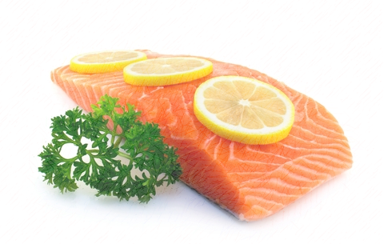
Diabetes
Guidelines: Aim for more whole, unprocessed foods in smaller portions
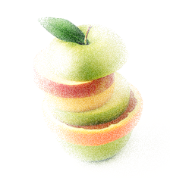
What foods can I eat?
Grains: half of your grains, pasta, bread, and cereal, should be whole grain (whole grain as first ingredient) | Meat: include fish twice per week, eggs, beans and soy based products, lean cuts of beef/pork, remove skin from poultry
Vegetables: eat more non- starchy vegetables: lettuce, mixed greens, spinach, mushrooms, peppers | Choose less starchy vegetables: corn, potatoes, peas, yam
Healthy fats: vegetable oils, avocado, olives, nuts, trans-fat  free margarine | 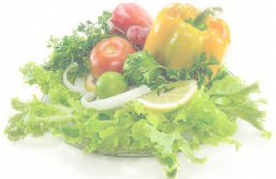  Dairy: 1% fat or skim milk, nonfat or low fat yogurt, reduced fat cheeses

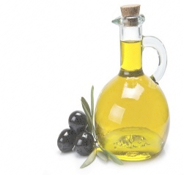
What foods should I avoid?
Products made from refined white flour  Added sugar (read ingredients and avoid high fructose corn syrup, corn syrup solids, sugar, honey, fructose, cane syrup)  Fruits in syrup, dried fruits with added sugar, fruit juice | Saturated fats- found in gravy, butter, cheese, and fried foods  Avoid trans fat (read label)  Baked goods, frozen desserts, gelatins, candy, jellies, syrups

Recommended Servings Per Meal

Serving vs portion
Serving is a standard amount of food used to calculate its nutritional value. Portion is the actual amount you choose to eat, which can include one or more servings. Individuals vary on how much carbohydrate they need per meal.

- 2-4 servings whole grain carbohydrate = 2/3-1 cup cooked brown rice = 2-3 slices whole wheat toast
- 2-3 servings protein = 3 oz cooked lean cut meat or fish = 1 open palm
- 2-4 servings vegetables = 1-2 cups cooked vegetable or 2-4 cups raw leafy vegetables = 2 hands cupped
- 1 serving dairy = 1 cup low fat milk = 1 fist
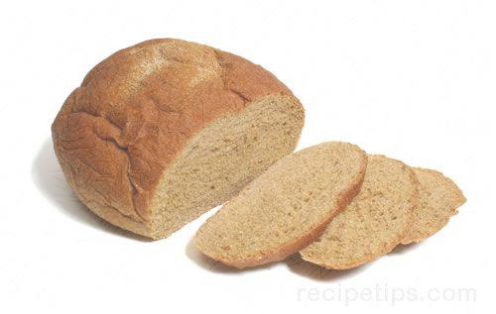
- 1 serving fruit = 1/2 banana or 1 small apple or 1/2 cup chopped fruit = 1 tennis ball
- 1 teaspoon ats/oil = 1 teaspoon olive oil = 1 tip of thumb to first knuckle
Paul Hom Asian Clinic Enya Meng 9/17/15

