Calorie Counting

What is a calorie?
Calories are the energy that fuel your body. A calorie is a unit of energy, defined as the heat required to raise 1 gram of 1 gram of water 1 degree Celsius. A kilocalorie is the heat required to raise 1 kilogram of water 1 degree Celsius.
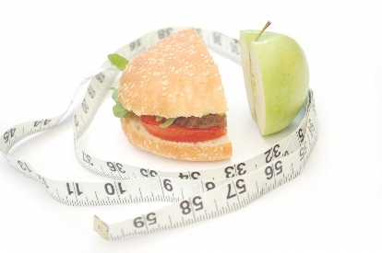
What is calorie counting?
Calorie counting is a meal planning method used to help keep track of blood glucose levels. After setting a limit to the maximum amount of carbohydrate to eat for a meal, a patient can use this measure to keep their blood glucose in target range, along with physical exercise and medication.

How much carbohydrate do I need?
Individuals vary in how much carbohydrate they need per meal. Finding the right amount for you may include many factors, such as physical activity level, age, gender, and current medications. It is generally recommended to have 45-60 grams of carbohydrate per meal. You may need more or less carbohydrates depending on your health status.

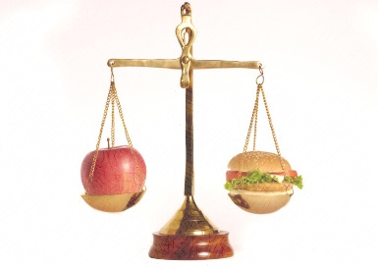
What foods have carbohydrates? What is equivalent to 1 serving (15 grams) of carbohydrates?
Grains: rice, oatmeal, barley, bread, cereal, pasta, crackers | 1 slice of bread or 1/3 cup rice
Vegetables: potatoes, peas and corn | 3 oz large baked potato or ½ cup corn
Fruit: bananas, plums, figs, grapes, and fruit juice | 4 oz piece of fresh fruit or ½ cup canned fruit
Dairy: milk and yogurt | 2/3 cup of plain fat free yogurt or ½ cup ice cream
Protein: pinto beans, soy products | ½ cup of black beans or 2/3 cup lima beans
Other: sodas, juice drinks, cake, cookies, candy, and chips | 2 small cookies or 1 tbsp honey

Where do I look for carbohydrates on the Food Label?
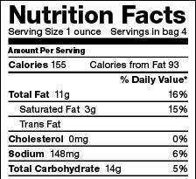
Look for the serving size for food at the top of the label and for
the total carbohydrate amount in the middle of the label. The
amount of total carbohydrate is specific for the serving size listed.
Paul Hom Asian Clinic Enya Meng 9/17/15

